|  |
| --- |
| Association of Computer professional  (acp) |
| Advanced Diploma Project 2 |
| CALCULATOR |
| July 2011 |
| **Submitted By**  **Mohammad Bappy Chowdhary**  **ACP Membership number: S12237** |
|  |

**Index**

**Contents Page No.**

**1.1 Project Objective --------------------------------------------------------------------------------- 2**

**1.2 Project Methodology ---------------------------------------------------------------------------- 2**

**1.3 Investigation --------------------------------------------------------------------------------------- 2**

**1.4 System Analysis ----------------------------------------------------------------------------------- 2**

**1.5 System Design ------------------------------------------------------------------------------------- 2**

**2.1 Main Interface Screenshot --------------------------------------------------------------------- 3**

**2.2 Flow Chart ------------------------------------------------------------------------------------------ 4**

**2.3 Coding ----------------------------------------------------------------------------------------------- 5**

**3.1 Testing Addition ---------------------------------------------------------------------------------- 9**

**3.2 Testing subtraction ------------------------------------------------------------------------------- 10**

**3.3 Testing Division ------------------------------------------------------------------------------------ 12**

**3.4 Testing Multiplication ---------------------------------------------------------------------------- 13**

**4.1 Dry run ------------------------------------------------------------------------------------------------ 14**

**4.2 Summarisation of test results ------------------------------------------------------------------ 15**

**5.1 System Limitation ---------------------------------------------------------------------------------- 15**

**5.2 Further Improvement ----------------------------------------------------------------------------- 15**

**5.3 Conclusion -------------------------------------------------------------------------------------------- 15**

**5.4 Examiner’s Comments ----------------------------------------------------------------------------- 15**

**Introduction**

A simple Calculator will be created for this project using most feasible programming language which is Java. It will be software which will be able to compute adding, subtracting, multiplying, dividing as a simple calculator will perform.

**1.1 Project objective**

. Simple Calculation

. Graphical User Interface Using Java Applet

. Portability

. User friendly

**1.2 Project Methodology**

This project is followed through a procedural method using the development life cycle which follows Investigation or finding the factors, System analysis, System Design, Testing and Maintenance.

**1.3 Investigation**

Investigating the problems and finding a way to solving them will be discussed in this stage. System procedure steps, system design concept will be discussed in this phase.

**1.4 System analysis**

According to the project for a calculator system analysis will be needed to find out the different functions of the software.

Logical design will be made in this phase for each of the function of the calculator according to user requirements.

**1.5 System design**

With the help of system analysis phase a calculator will be designed using Java Applet. Using GUI, creating buttons, frames and different fields a calculator will be formed.

To help the design procedure a flow chart will be made to help the workflow.

Testing will be done after completing of the design to ensure the software is working.

**2.1 Main Interface Screenshot of JApplet Calculator.**

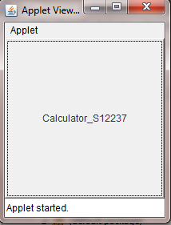

**After clicking the applet window the calculator appears like this:**

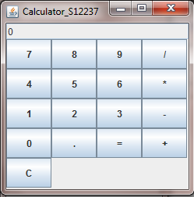

**2.2 Flow chart of work procedure steps for actual design:**

**2.3 Actual Code for an applet Calculator**

import java.awt.*;

import java.awt.event.*;

import javax.swing.*;

public class ch_1 extends JApplet implements ActionListener {

public void init() {

Button calcButton = new Button("Calculator_S12237");

calcButton.addActionListener(this);

Container contentPane = getContentPane();

contentPane.add(calcButton);

}

public void actionPerformed(ActionEvent evt) {

if (calc.isVisible())

calc.setVisible(false);

else

calc.show();

}

private JFrame calc = new CalculatorFrame();

}

class CalculatorPanel extends JPanel implements ActionListener {

public CalculatorPanel() {

setLayout(new BorderLayout());

display = new JTextField("0");

display.setEditable(false);

add(display, "North");

JPanel p = new JPanel();

p.setLayout(new GridLayout(5,4 ));

String buttons = "789/456*123-0.=+C";

for (int i = 0; i < buttons.length(); i++)

addButton(p, buttons.substring(i, i + 1));

add(p, "Center");

}

private void addButton(Container c, String s) {

JButton b = new JButton(s);

c.add(b);

b.addActionListener(this);

}

public void actionPerformed(ActionEvent evt) {

String s = evt.getActionCommand();

if ('0' <= s.charAt(0) && s.charAt(0) <= '9' || s.equals(".")) {

if (start)

display.setText(s);

else

display.setText(display.getText() + s);

start = false;

} else {

if (start) {

if (s.equals("-")) {

display.setText(s);

start = false;

} else

op = s;

} else {

calculate(Double.parseDouble(display.getText()));

op = s;

start = true;

}

}

}

public void calculate(double n) {

if (op.equals("+"))

arg += n;

else if (op.equals("-"))

arg -= n;

else if (op.equals("*"))

arg *= n;

else if (op.equals("/"))

arg /= n;

else if (op.equals("="))

arg = n;

else if (op.equals("C"))

arg = 0;

display.setText("" + arg);

}

private JTextField display;

private double arg = 0;

private String op = "=";

private boolean start = true;

}

class CalculatorFrame extends JFrame {

public CalculatorFrame() {

setTitle("Calculator_S12237");

setSize(250, 250);

Container contentPane = getContentPane();

contentPane.add(new CalculatorPanel());

}

}

**3.1 Testing Addition**

**Screenshots of Adding 35.7 with 276.98**

**First value input screen shot.**

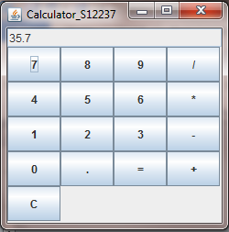

**Second value input screen shot.**

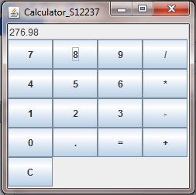

**Output screenshot of the added result**

. 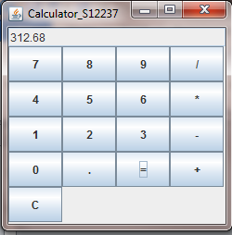

**3.2 Testing Subtraction**

**Screenshots of subtracting value from 549 to 398.**

**First value input screenshot.**

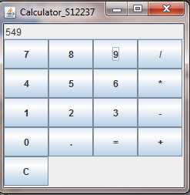

**Second Value input screenshot.**

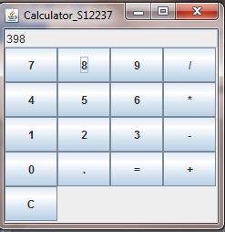

**Output of the subtraction**

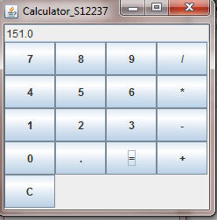

**3.3 Testing Division**

**. A division of 57 by 11**

**First value input screenshot followed by “/” button.**

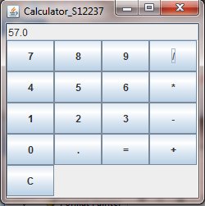

**Second value input screenshot**

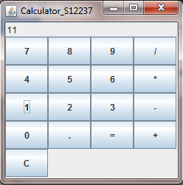

**Output screenshot of the Division**

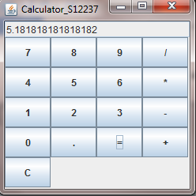

**3.4 Testing Multiplication**

**Multiplication of 45 with 23**

**First value input screenshot with”*” button clicked.**

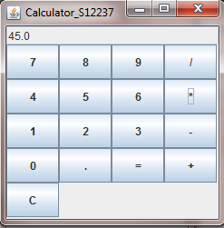

**Second value input screenshot.**

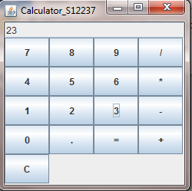

**Output screenshot of the multiplication.**

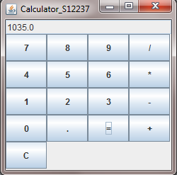

**4.1 Dry Run**

|  |  |  |  |  |  |
| --- | --- | --- | --- | --- | --- |
| Test No | Operation | First Value  Input | Second Value  Input | Output | Validity  Yes/No |
| 1 | + | 35.7 | 276.98 | 312.68 | Yes |
| 2 | - | 549 | 398 | 151.0 | Yes |
| 3 | / | 57 | 11 | 5.1818 | Yes |
| 4 | * | 45 | 23 | 1035 | Yes |

**4.2 Summarisation of test results**

|  |  |  |  |  |
| --- | --- | --- | --- | --- |
| **No** | **Test names** | **Expected result** | **Actual Result** | **Comment** |
| **1** | JApplet GUI test | No error | As expected | Valid result |
| **2** | Test of Addition | No error | As expected | Valid result |
| **3** | Test of Subtraction | No error | As expected | Valid result |
| **4** | Test of Multiplication | No error | As expected | Valid result |
| **5** | Test of Division | No error | As expected | Valid result |

**5.1 System Limitation:**

As we know that the project was design to create a basic calculator, there are no scientific operations included.

**5.2 Further Improvement**

Calculating percentage could be added in this calculator.

Memory saving option could be added as well.

**5.3 Conclusion**

As simple calculator software a well organised documentation and design was behind this project. Requirements by user can modify the software.

Using java programming language for this software practice was needed indeed. Further modification can be done if required.

**5.4 Examiner’s Comments**